Project Design Phase-II
Technology Stack (Architecture & Stack)

Date | 31 January 3035
Team ID | LTVIP2026TMIDS76805
Project Name | Online Payments Fraud Detection using Machine Learning
Maximum Marks | 4 Marks

Technical Architecture:
The Deliverable shall include the architectural diagram as below and the information as per the table1 & table 2
Example: Online Payments Fraud Detection using Machine Learning
Guidelines:
Include all the processes (As an application logic / Technology Block)
Provide infrastructural demarcation (Local / Cloud)
Indicate external interfaces (third party API’s etc.)
Indicate Data Storage components / services
Indicate interface to machine learning models (if applicable)
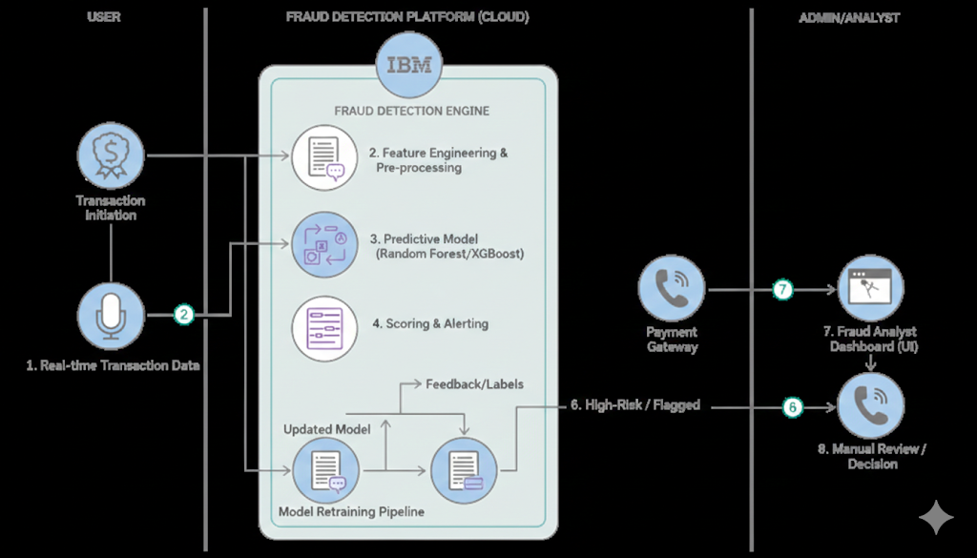

Table-1 : Components & TechnoloS.No | Component | Description | Technology
1 | User Interface | Web interface where users enter transaction details and view fraud prediction results | HTML, CSS, JavaScript, Bootstrap
2 | Application Logic-1 | Handles user input validation and request processing | Python, Flask
3 | Application Logic-2 | Fraud detection processing logic | Scikit-learn, Pandas, NumPy
4 | Application Logic-3 | Fraud probability calculation and result display | Flask Backend
5 | Database | Stores user details and transaction records | MySQL
6 | Cloud Database | Cloud-based storage for scalability (optional) | Firebase / MySQL Cloud
7 | File Storage | Stores trained machine learning model (.pkl file) | Local File System
8 | External API-1 | Email alert service for suspicious transactions | SMTP / Gmail API
9 | External API-2 | OTP verification service | Twilio API
10 | Machine Learning Model | Predicts whether a transaction is Fraud or Safe | Random Forest / XGBoost
11 | Infrastructure (Server / Cloud) | Deployment of application on local or cloud server | Local Server / AWS / Render

Table-2: Application Characteristics:
S.No | Characteristics | Description | Technology
 | Open-Source Frameworks | List the open-source frameworks used | Technology of Opensource framework
 | Security Implementations | List all the security / access controls implemented, use of firewalls etc. | e.g. SHA-256, Encryptions, IAM Controls, OWASP etc.
 | Scalable Architecture | Justify the scalability of architecture (3 – tier, Micro-services) | Technology used
 | Availability | Justify the availability of application (e.g. use of load balancers, distributed servers etc.) | Technology used
 | Performance | Design consideration for the performance of the application (number of requests per sec, use of Cache, use of CDN’s) etc. | Technology used

Table-2: Application Characteristics
S.No | Characteristics | Description | Technology Used
1 | Open-Source Frameworks | Open-source tools used for development | Flask, Scikit-learn, Bootstrap
2 | Security Implementations | Secure authentication, encrypted communication, session control | SHA-256, HTTPS, Flask-Login
3 | Scalable Architecture | 3-Tier architecture allowing scaling of backend and database | Flask + MySQL + Cloud Hosting
4 | Availability | Application accessible 24/7 using cloud infrastructure | AWS / Render Cloud
5 | Performance | Real-time fraud prediction with optimized ML model and minimal response time | Optimized ML Model, Caching

